

**ENGN8260 /​ COMP8260 |** Professional Practice 2

Week 7 **Responsible Innovation Project audit**

Workshop Activity

Before and during the teaching break you collected all data you required for your Responsible Innovation Project. You will have this data displayed in tables, charts, histograms, etc. Interpret and make meaning from your data using the following prompts. Iterate project information based on new insights.

1. **Clarifying new insights using DT tools** *(Take 15 mins for this task)*

New insights lead to new understanding. Iterate the following DT tools based on new insights.

* 1. Project Client Map #7 & #9

* 1. Value Proposition Canvas

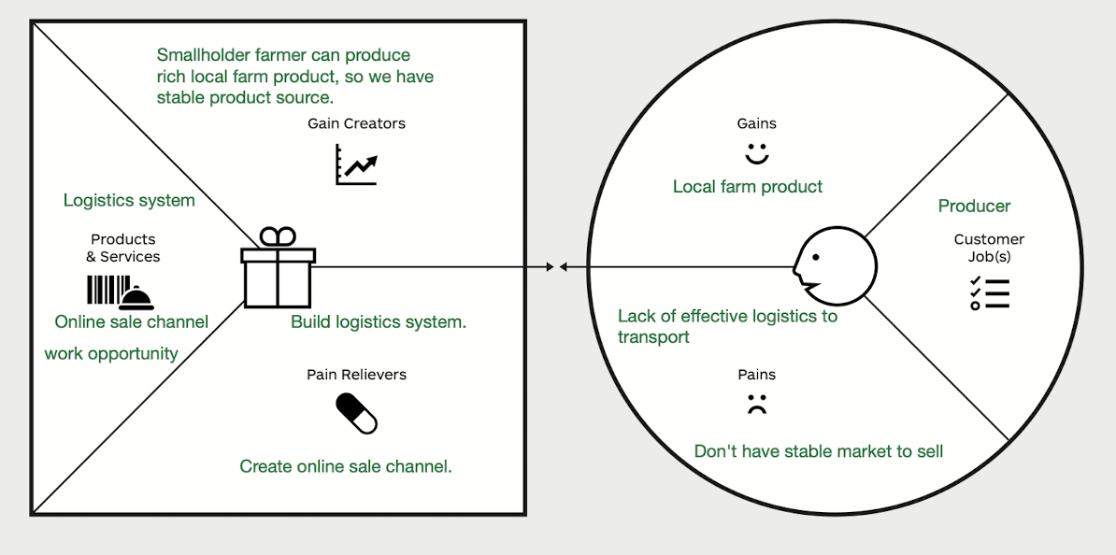

1. **Making sense of your data** *(Take 30 mins for this task)*

Summarise your qualitative and quantitative results briefly using OSEM. Include key facts, concepts or theory from your background research to help explain the results as needed.

*O = Obvious; S = Specify; E = Evidence; M = Meaning*

Food losses

Food losses refer to the decrease in edible food mass throughout the part of the supply chain that specifically leads to edible food for human consumption. Food losses take place at production, postharvest and processing stages in the food supply chain

Food waste

Food losses occurring at the end of the food chain (retail and final consumption) are rather called “food waste”, which relates to retailers’ and consumers’ behavior.

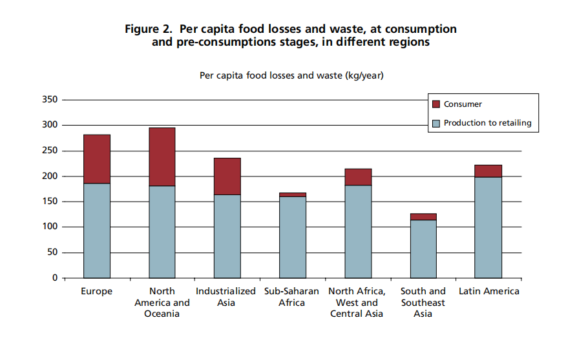

O:There is serious food loss/waste in both developed and underdeveloped regions.

S:The reasons for food loss and waste in developed and underdeveloped regions vary a lot. There are serious wastes in the consumer and production to retailing stages in developed regions, and waste is mainly generated in the production stage in underdeveloped regions.

E: Per capita food wasted by consumers in Europe and North-America is 95-115 kg/year, while this figure in sub-Saharan Africa and South/Southeast Asia is only 6-11 kg/year.

M: People in underdeveloped areas are unwilling to waste food subjectively and behaviorally, but because of force majeure in the production stage, people are forced to throw away food. These reasons includes people's planting technology, storage technology, natural environment, transportation technology, etc. And by improving these technologies, food waste can be greatly reduced.

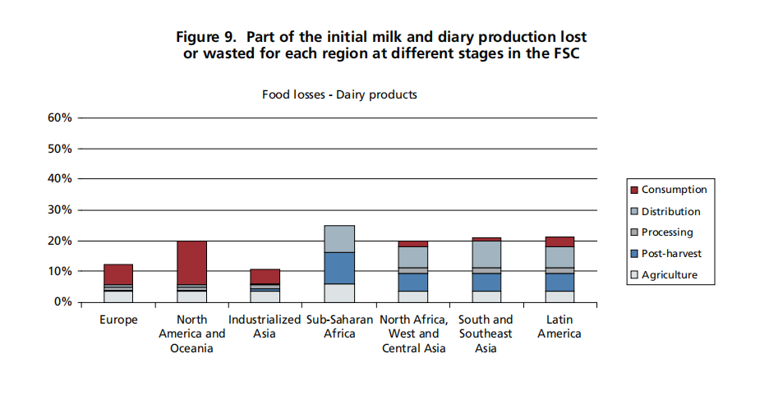

O: For dairy products that are not easy to preserve, food waste and loss are more serious in underdeveloped countries.

S: Food losses in developed countries are mainly in the consumption stage, while food losses in underdeveloped countries are mainly concentrated in the post-harvest and distribution stages.

E: In North America, about 15% of food waste is in consumption, while in sub-saharan Africa, there is almost no food waste in the consumption phase.

M: In the post-harvest and distribution stages, dairy products have strict requirements on the storage and transportation environment. In developed areas, with advanced storage technology and developed transportation networks, this loss is minimized. If the developing regions have the same perfect storage and transportation technology, it will effectively reduce food loss.

1. **Iterating the project scope** *(Take 15 mins for this task)*

Iterate the elements in this table (from your project proposal) based on insights from your data.

|  |  |
| --- | --- |
| **Element** | **Detail** |
| Project title | Effective logistics and market for Smallholder farmers |
| POV | [Do you need to reframe your POV?]  Smallholder farmers need effective logistics and stable market to ensure selling because these time-sensitive food need suitable storing condition and effective transport and selling network. |
| Outcome | Provide a transportation and online sales platform for smallholder farmers, broaden their sales channels, provide efficient and safe transportation methods, and reduce unnecessary product losses. |
| Output | An online interactive platform where smallholder farmers, transportation companies, processing and purchasing companies can publish and inquire information and reach cooperation. |
| Quality Criteria | Safety.  Security and fairness. Every stakeholder is treated fairly and they are in the same position in the transaction. Their personal information will be protected.  Income of smallholder farmers. Determine whether users benefit from the platform by analyzing their income.  Food losses/waste. Transportation and storage are important reasons for food losses. If the amount of food losses drops, it means that the platform can solve their problems. |
| Customer(s) | No. Smallholder farmers. |

1. **Redefining project requirements** *(Take 30 mins for this task)*

Iterate the requirement in this table (from your project proposal) based on insights from your data.

Project requirements have been sourced from **<add details>**. Project requirements identified to date are detailed below. *[Adjust the rows and columns and text below to reflect requirements identified for your project challenge.]*

|  |  |  |  |  |  |
| --- | --- | --- | --- | --- | --- |
| **Requirement category** | **Sub-cat** | **Req ID** | **Requirement** | **Owner** | **Priority** |
| [User requirement] | UR-1 | 1.0.1 | [Ability to collect and analyse the problems most of the small-scale peasants in global south encounter about expand product sales and establish a logistics platform (system) for solving these problems] | [Puxi Cao,  Yifan Zhou,  Han Zhang,  Chenhao Zhang,  Hang Su] | [High] |
|  |  |  |  |  |  |
| [Technical requirement] | TR-1 | 2.01 | [The establishment of online warehousing and trading platform which is compatible with the local infrastructure condition] | [Puxi Cao,  Yifan Zhou,  Han Zhang,  Chenhao Zhang,  Hang Su] | [High] |
|  |  |  |  |  |  |
| [Legal requirement] | LR-1 | 3.01 | [The established online platform/software does not violet the local laws and regional regulations] | [Puxi Cao,  Yifan Zhou,  Han Zhang,  Chenhao Zhang,  Hang Su] | [High] |
|  |  |  |  |  |  |
| [Other…standards, regulations, etc] | ER-1 | 4.01 | [The implementation of the established online platform/software and the practice of this project does not result in non-ethical consequence (not violating the local customs of life and religion, not result in local economic order disrupted etc.] | [Puxi Cao,  Yifan Zhou,  Han Zhang,  Chenhao Zhang,  Hang Su] | [Medium] |
|  |  |  |  |  |  |

1. **Evaluating the research design** *(Take 20 mins for this task)*

Evaluate the research design and data collection procedure, making comments about the effectiveness. Suggest changes in the procedure and/or possibilities for further work.

|  |  |
| --- | --- |
| **Criterion** | **Notes** |
| 1. What was effective about your research design? | It can improve the transportation efficiency of agricultural products and promote sales, and help smallholder farmers sell their products, thereby effectively increasing their income. |
| 1. What changes to the research design would you suggest to your client? | On the current basis, increase warehousing and transportation links, and help smallholder farmers find buyers. |
| 1. What were the ethical considerations in your research design? | * Whether it can benefit every user fairly * Whether it has negative impacts on some stakeholders * Whether the system is convenient for everyone, such as the elderly and the disabled |
| 1. Could you have collected data in a more efficient way to aid and support analysis? | We can directly ask the people who use the system and the small farmers in the area who do not use the system of their needs and what should be improved. Or build a questionnaire survey and feedback mechanism in the system to collect feedback. |
| 1. Did you function effectively as a team?   How do you know? | I think so, because everyone performs their duties and contributes their own ideas. |

1. **Evaluating the project team using feedback from facilitator (*and mentor)**

|  |  |
| --- | --- |
| **Criterion** | **Notes** |
| 1. What did you learn from feedback? |  |
| 1. What will your team change based on feedback? |  |
| 1. How will you make these changes? What is the timeframe for the changes? |  |